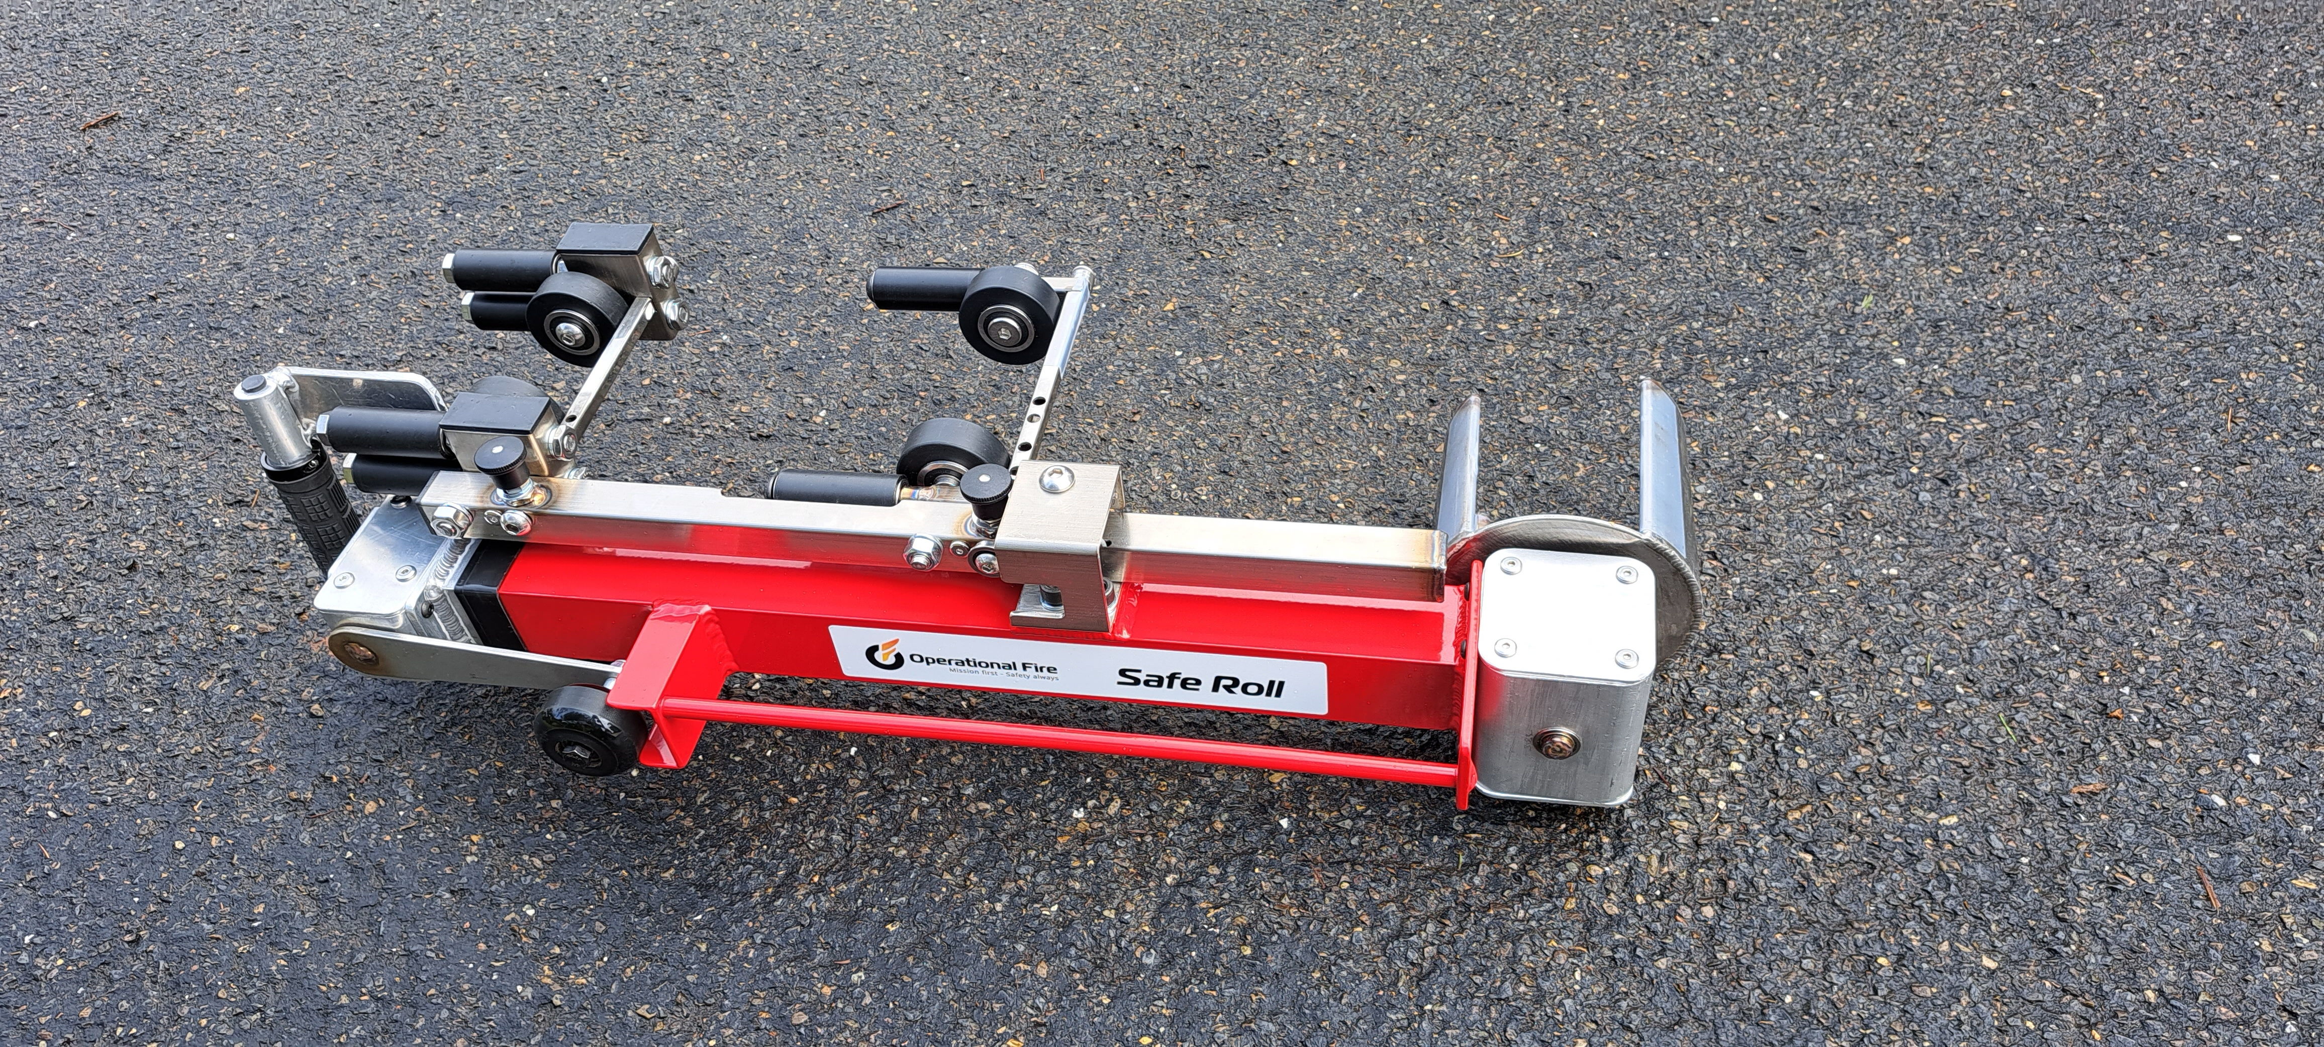

Equipment Information

‘Safe Roll’
Lay Flat Hose
Roller
Prepared by Operational Fire

Suggestion and feedback form:
Any feedback please fill in the feedback form and submit it to operationalfire@outlook.com
Copyright © 2024 by the Operational Fire Pty. Ltd. All rights reserved.
Copyright subsists in this publication. Apart from any use permitted by the Copyright Act 1968 (Cth), no part of this publication may be published or transmitted in any form or by any means electronic or mechanical including photocopying and/or microfilm recording or by any information storage and retrieval system, nor may it be communicated, modified, commercialised or altered, without the express permission in writing from the publisher, Operational Fire Pty. Ltd
This publication was developed with the assistance, cooperation and source material provided by a number of third parties, including Operational Fire Pty. Ltd. and information proprietarily owned by Operational Fire Pty. Ltd.
Operational Fire Pty. Ltd. makes no representations as to the accuracy of the information or its sufficiency or suitability for the application to which any individual user may wish to put it. Operational Fire Pty. Ltd. accepts no liability for any use of the information or reliance placed on it and no responsibility is accepted for events or damages resulting from its use.
Published by: Operational Fire Pty. Ltd.
Version: 1.0

CONTENTS
‘Safe Roll’ Lay-Flat Hose Roller Instructions
Description.......................................................................................................................... 1
Use..................................................................................................................................... 2
Construction........................................................................................................................ 2
Operator Safety Considerations……….…..…………………………………………………… 2
Safety Precautions……..……………………………..…………………………………………. 3
Hazard Avoidance…………………………………………………………………………….…. 3
Operation: Coiling a hose: Two-layered (‘Dutch’) roll /Coupling (‘straight’) roll / Twin (Double) Donut …………….………………………….………………………………………………4
- Hose preparation………………………………………………….……………………… 4
- Device Preparation.………………………………………….……………………………4
- Hose loading..……………………………….…………………………………………….5
  - Two layered ‘Dutch’ – page 5
  - Coupling / ‘Straight’ – page 6
  - Twin / Double Donut – page 6
- Effecting a hose roll……………………………………………………………………….8
- Releasing Safe Roll from the hose coil…………………………………………………9
- Stowing Hose…………………………………………………………………………….. 10
- Stowing Safe Roll………………………………………………………………………... 10
Cleaning.............................................................................................................................11
Maintenance.......................................................................................................................11

DESCRIPTION

Safe Roll is a portable, single operator, lay-flat hose roller. Lightweight and compact in size it can be used on the fire-ground or at station. It requires no electrical, hydraulic or pneumatic operations and requires minimal locker storage space when not in use.

The single operator coils the hose with an upright body position allowing for excellent manual handling. As Safe Roll guides the hose into itself, the operator is able to coil the hose with full situational awareness of their surrounds. Safe Roll is able to underrun / drain water out of typical attack hoses lines (~38mm diameter and less), reducing operator carcinogen exposure.

Safe Roll has two cylindrical rollers mounted on the body and a crank driven Bottom Drum. By pushing the roller and cranking the handle, tension is created in the hose roll allowing a tighter and more consistent roll than rolling by hand. By using various combinations of the two rollers and the drum, it is possible to coil hoses in a two-layered (‘Dutch’) style, around the coupling (‘straight’ roll) or in the twin-donut style.

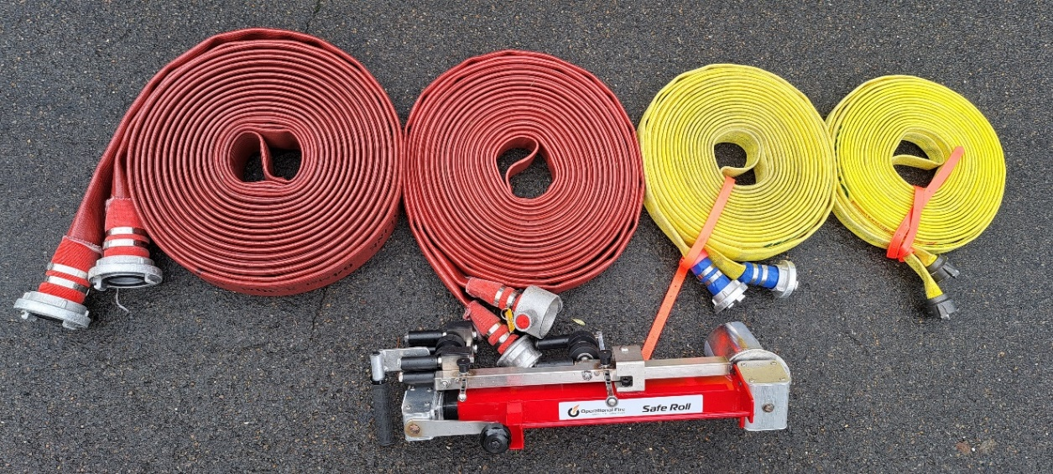
Figure 1: Safe Roll and correctly rolled hose+.

USE

Safe Roll can:
- Roll numerous hose diameters (19-70mm) and various lengths (7.5 – 30m+).
- Coil hose in the three main styles used by fire services today (two-layered ‘Dutch’ rolls, ‘Straight’ rolls around the coupling and ‘Twin-donut’).

CONSTRUCTION

Safe Roll has a crank handle, internal collapsible drive shafts and a pair of 90-degree gearboxes that drive the Bottom Drum.

Safe Roll comprises four main components:
- Telescopic aluminium tubes which house the internal drive shafts.
- Upper and lower nylon rollers that the hose is loaded upon.
- Stainless steel Bottom Drum that either the bight of the hose or the coupling is placed in forming the start of the hose roll.
- A stainless-steel Release Arm, which when the release pad is used will release the hose from the Bottom Drum.

OPERATOR SAFETY CONSIDERATIONS

- Take care to protect their health and safety
- Not endanger the safety of others
- Ensure correct use of equipment
This equipment is not to be operated unless the operator is trained or the trainee is under the supervision of a trained operator.

SAFETY PRECAUTIONS

- Be attired in the appropriate level of PPE: Safety gloves at a minimum
- Ensure the hose is loaded correctly for the type / style of hose to be rolled. If at any point significant resistance is experienced while rolling, stop and check what may be causing the resistance.
HAZARD AVOIDANCE

- When extending, do not allow Safe Roll’s upper and lower sections to violently extend.
  - Do not overextend.
- Ensure that the locking pin has engaged prior to using Safe Roll.
  - Ensure the locking pin has engaged after collapsing the roller for storage.
- Ensure that you do not place hands near the rollers while rolling hose.
- The only parts of Safe Roll that an operator needs to come into contact with for correct device operation are (Figure 2);
  - Crank Wheel (attached to the Crank Handle)
  - Grab Handle (the black, rubberised grip section only); ensure fingers / thumb do not protrude into the path of the Crank Handle whilst operating / collapsing.
  - Black Spring Pins for extending / collapsing
  - Carry Handle for carrying / removing Safe Roll from the hose post coiling.
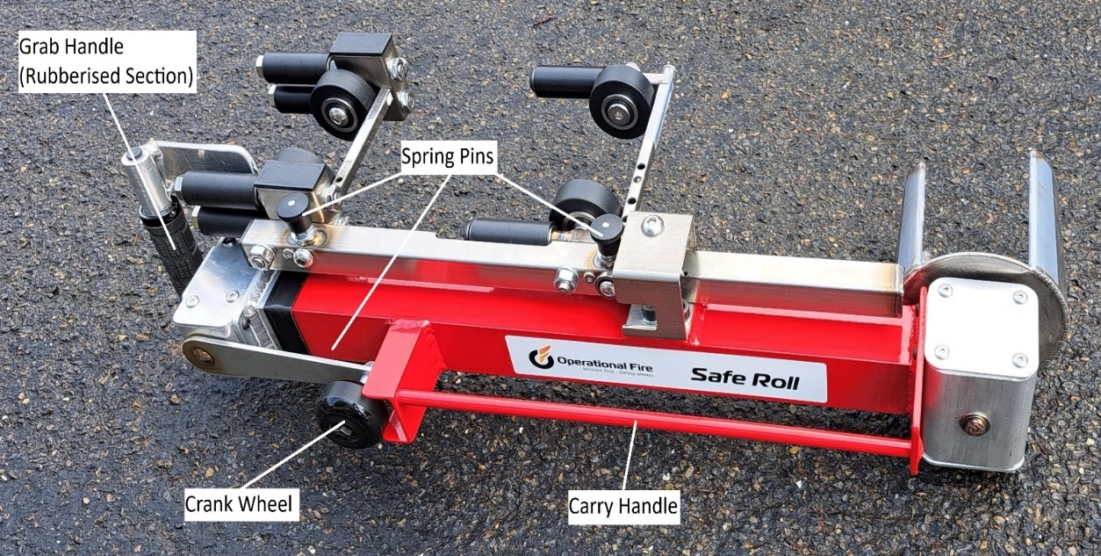
Figure 2: there are only 4 points an operator requires to be in contact with during correct operation.

OPERATION

Coiling a hose: Two-layered (‘Dutch’) roll / Coupling (Straight’) roll / Twin (Double) Donut

- Hose preparation:
  - For hoses greater than ~38mm underrun the hose as normal to remove excess water.
  - Lay the hose out in preparation for the style that the operator is going to roll the hose (Dutch, Straight or Twin-Donut) in the same fashion that would be done for a hand rolled hose.
    - Notes for two-layered ‘Dutch’ roll: Safe Roll has been designed specifically to be used by a single operator. As Safe Roll guides the two layers of the hose into the device it is not imperative to have both hose layers perfectly laid on top of each other as per a hand roll and will operate better with a slight ‘V’ set up to the hose (see Figure 3 below.)

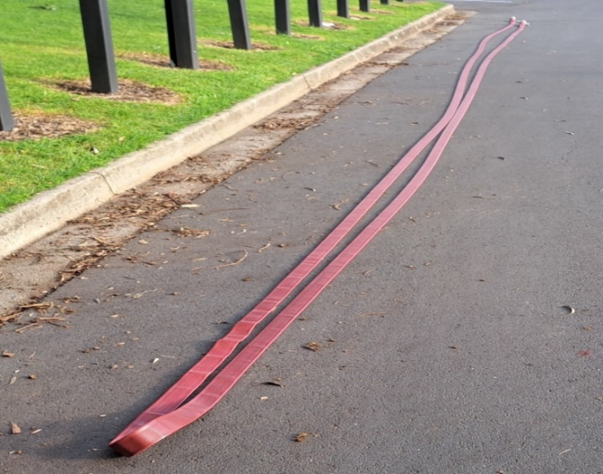
Figure 3. How to set up hose prior to rolling for a ‘Dutch’ roll.

- Device preparation:
  - Pull the pin located on the side guide rollers and select the hose size that you are about to roll. (Figure 4 below).
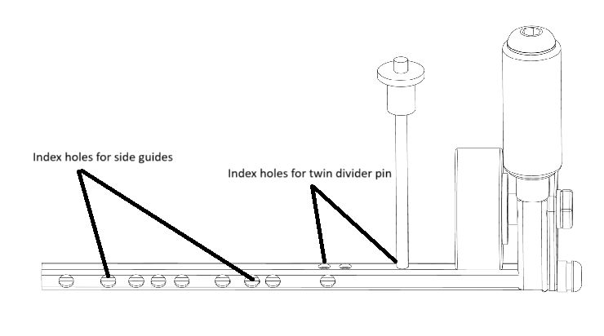
Figure 4. How to select hose size for side guides prior to rolling.

  - Pull the Spring Pin located under the grab handle on the main body and extend Safe Roll to full length. Ensure the spring pin is locked when Safe Roll is fully extended.

- Hose loading: There is a diagram located on Safe Roll to assist the operator to load the hose correctly.
Safe Roll will underrun (drain) attack lines (~38mm diameter and less) so there is no need to underrun prior to rolling. For larger diameters the hose will still need to underrun as normal.

  - Two-layered ‘Dutch’ roll: (Figure 4).
    - Grab the hose bight and pull the bight through the device
    - Place the top hose layer over the top of the top roller.
    - Place the bottom hose layer over the bottom roller.
    - Loop the hose bight around one of the Bottom Drum’s semi-cirlces.

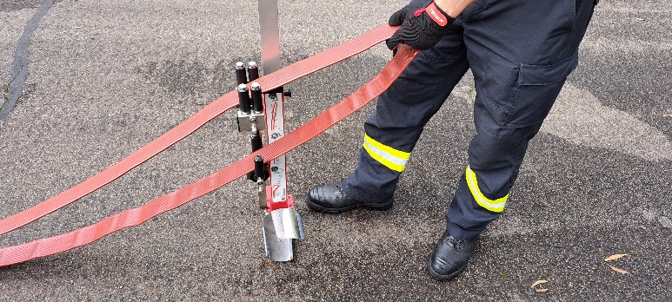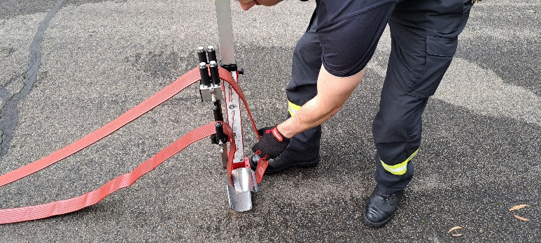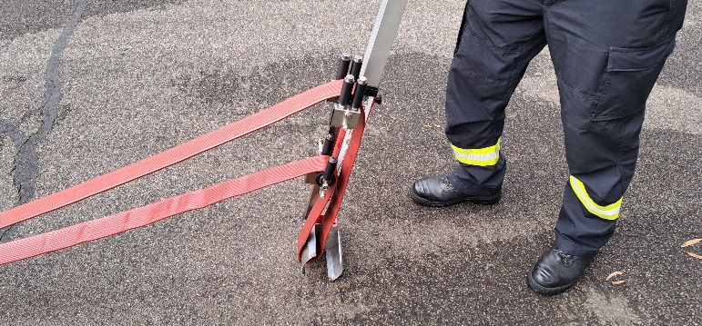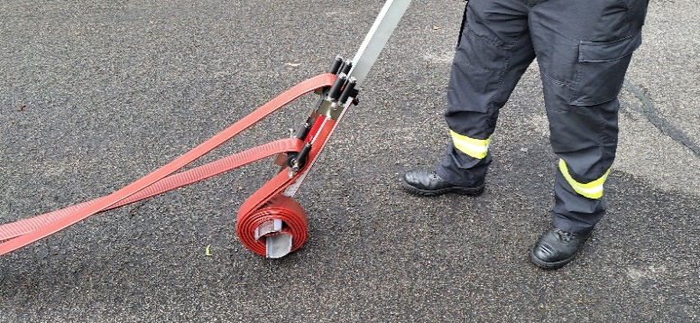

Figure 4. How to load for a two-layered ‘Dutch’ style roll
To view YouTube Video click below link:
How to roll 64mm hose Dutch / donut style - Safe Roll hose roller

  - Coupling / Straight roll: (Figure 5 below).
    - Place coupling inside the Bottom Drum.
    - Place the single hose line over the bottom roller guide.
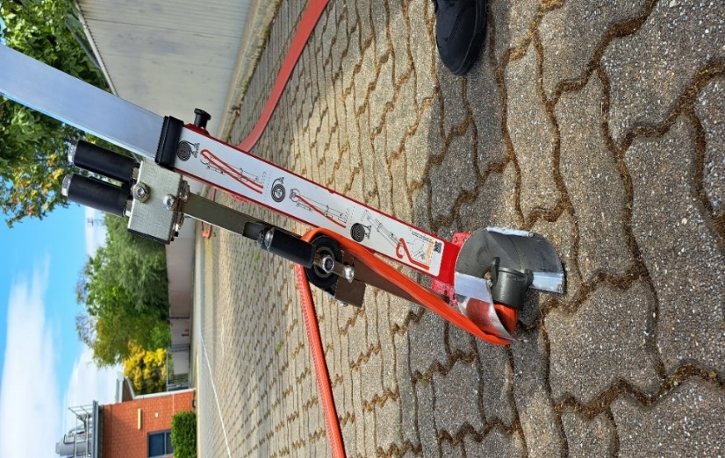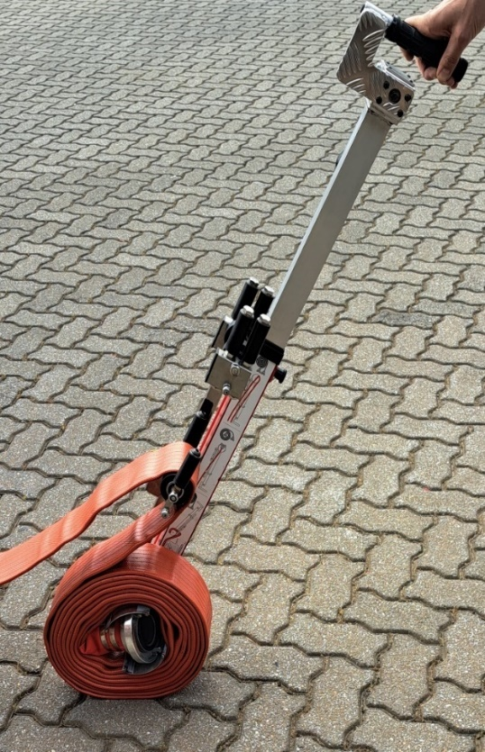
Figure 5. How to load for a coupling / ‘Straight’ roll
To view YouTube video click below link:
How to roll - 64mm hose coupling / Straight roll with the Safe Roll hose roller

  - Twin / Double Donut roll (25mm grassfire packs)
Spring pin twin divider
- Press the top twin divider spring pin in and remove the twin divider rod. (figure 6)
- Open the bottom slide guide to the desired length and place the twin divider rod into the twin divider index hole.
- Ensure twin divider rod is secure.
- Place the hose bight over one of the bottom drum’s semi-circles, and both layers of hose over the bottom roller. Place a hose layer either side of the Twin Divider (Figure 6 below).
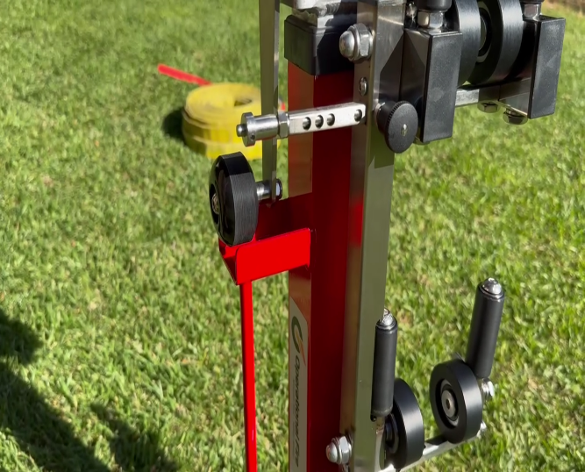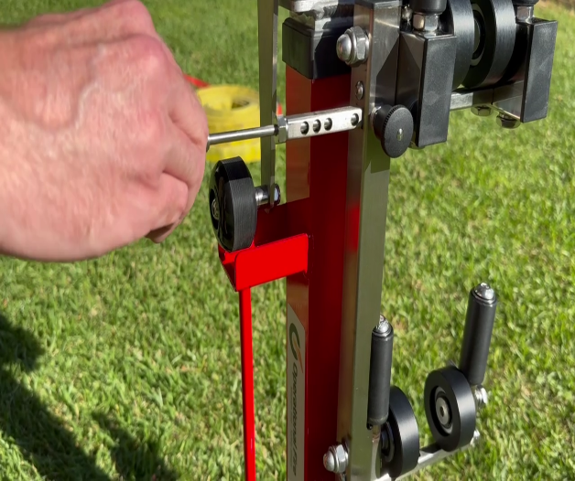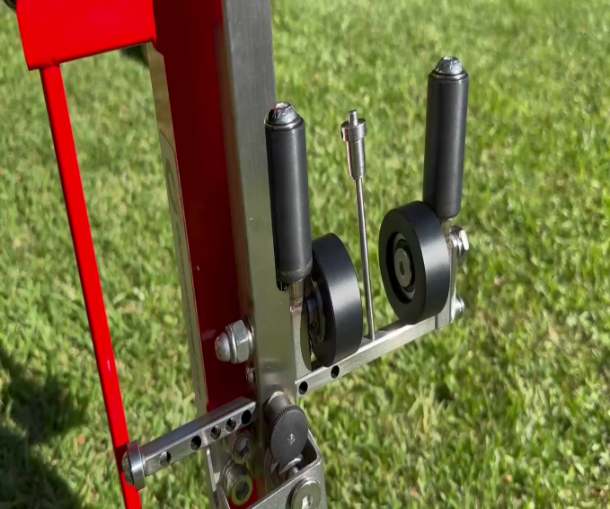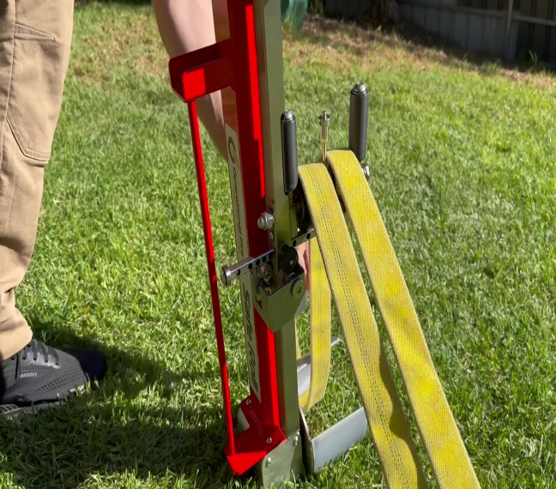

Internal twin divider
    - Pull the Spring Pin for the bottom guide roller and extend the extension bar to full length.
    - Raise the Twin Divider located inside the bottom extension bar by lifting the tab. Hold Twin Divider in place and close the extension bar to the 50mm hose (middle hole) locator hole. (Figure 6).
    - Place the hose bight over one of the bottom drum’s semi-circles, and both layers of hose over the bottom roller. Place a hose layer either side of the Twin Divider (Figure 6 below).
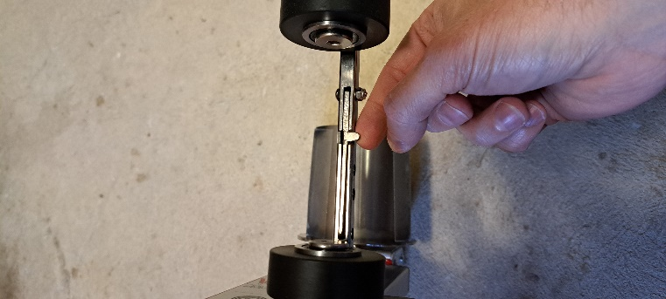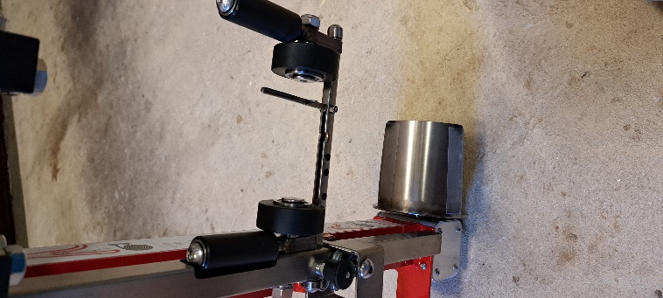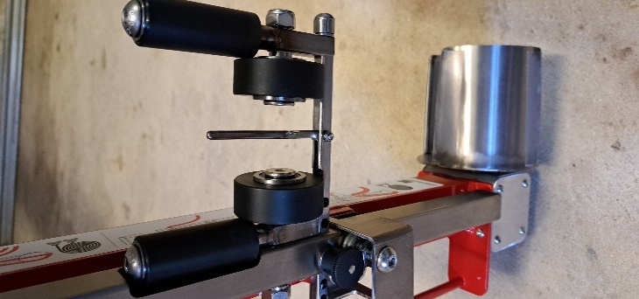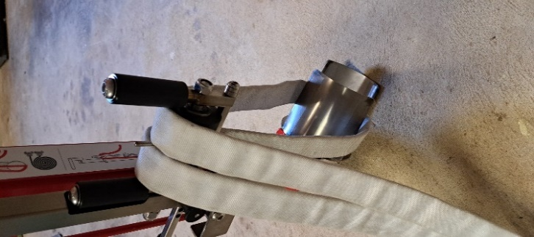

Figure 6: Divider extended and hose loaded in preparation for a ‘Twin / Double Donut’ roll.
To view YouTube video click below link:
How to roll 25mm hose using the twin divider - Safe Roll hose roller

- Effecting a hose roll: Two layered (‘Dutch’) / coupling (‘Straight’) rolls / Twin (Double) Donut rolls
  - Take hold of the black grip section of the Grab Handle and begin to turn the crank handle to take up any slack of the hose.

Important: The more ‘slack’ removed from the hose layer(s) prior to rolling, the better / easier Safe Roll will work.

Warning: while there is ample room between the grab handle and the crank handle, operators must be aware to not place their fingers / thumbs in the path of the Crank Handle whilst operating the device.

  - Maintain Safe Roll at approximately a 45-degree angle. More ‘crank handle’ use can be added for a tighter hose roll if required.
    - Notes for Coupling / ‘Straight’ roll: As some coupling designs tend to be longer than the space available in Safe Roll’s Bottom Drum the hose coil can initially be non-round in shape. It may be necessary for the operator to slightly lift the Safe Roll to initially get the hose roll started. This may only be necessary for the first 2-3 revolutions.

    - Notes for Twin / Double Donut roll: Due to the less stable nature of the hose diameters used in the ‘Twin Donut’ style (due to their smaller footprint), it is important that that most of the work of coiling the hose is done by the crank handle ensuring as tightly coiled hose as possible.

  - Continue pushing / cranking allowing the hose to be drawn into the hose roll via Safe Roll’s roller(s).
  - When nearing the end of the roll the operator must slow down so that the coupling(s) are drawn onto the hose roll. The Operator is required to lift the couplings up and over the guide rollers.
Warning: Possible injury to the operator and damage to the coupling(s) could occur if the hose coupling(s) are allowed to be rolled in an uncontrolled manner.
  - When the hose roll is complete keep slight tension on the Crank Wheel to keep the coupling locked into the device. Then gently rest the Safe Roll on the ground. This also ensures that the couplings are free from Safe Roll’s workings when the hose coil is to be released.
  - Lay Safe Roll and the hose coil over onto their left hand side (Safe Roll will be on top of the hose coil as seen in Figure 7 below).

- Releasing Safe Roll from the hose coil:
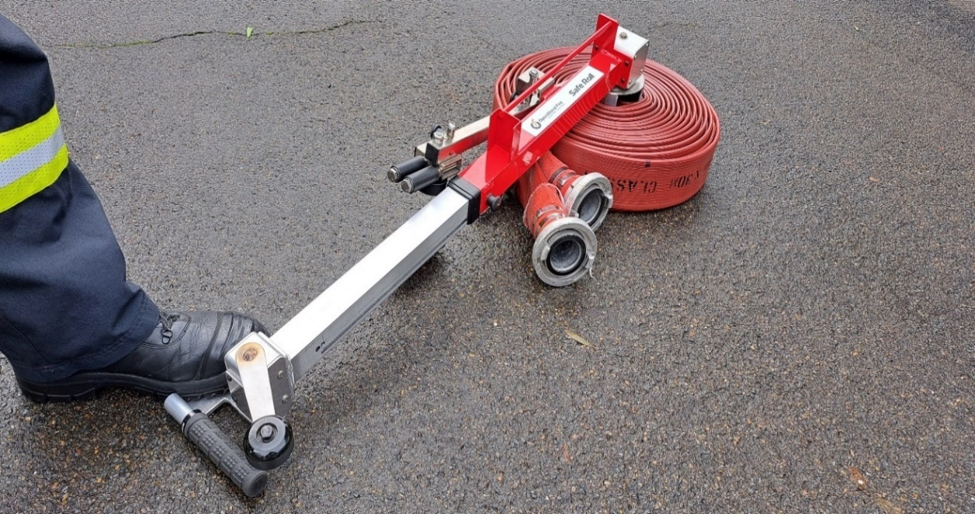
Figure 7: Releasing the device from a hose coil (hose diameter greater than ~38mm)

  - For hoses larger than 38mm gently press down on the foot actuated Release Pad. This activates the Release Arm breaking Safe Roll’s grip on the hose coil (Figure 7).
    - For stickier hose materials, the operator may be required to gently tap the release pad several times to loosen Safe Roll from the hose coil.
Warning: The Release Pad and Safe Roll is not designed to carry the full weight of an operator. Damage to the device and injury to the operator may occur if the operator puts their full weight on any of Safe Roll’s workings.
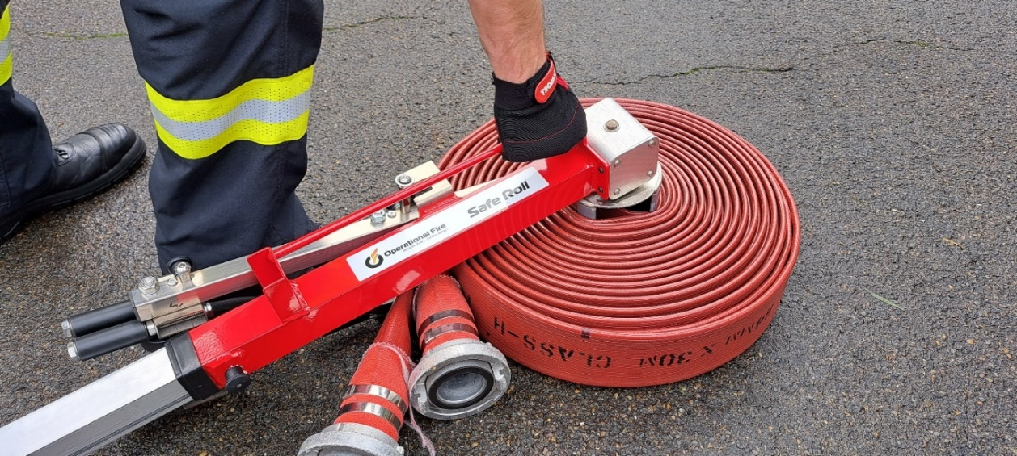
Figure 8: Removing Safe Roll from a hose coil. For safety, only use the carry handle pictured.

  - Remove Safe Roll from the remainder of the hose coil via the carry handle only ensuring that couplings, hose and operator are free from Safe Roll’s workings (Figure 8 above).

- Stowing hose:
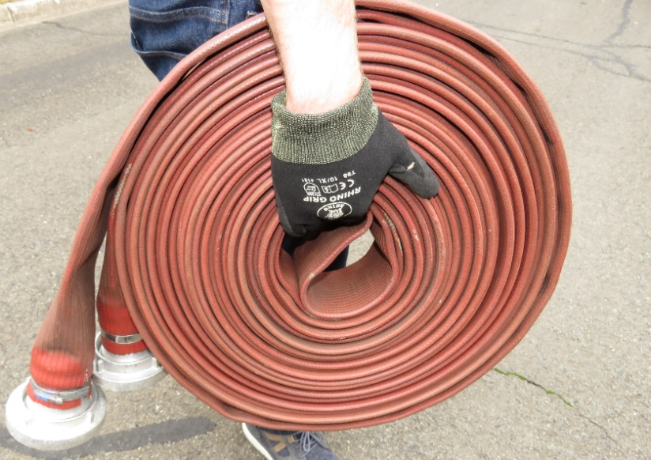
Figure 9: The improvement in manual handling created by Safe Roll’s centre carry area in a hose coil.

Stowing hose: Safe Roll’s design leaves a space in the centre part of the hose coil that is now used to carry hose for appliance / station hose storage, greatly improving manual handling (Figure 9).

- Stowing Safe Roll

  - Stand Safe Roll vertically and pull the black Spring Pin located under the handle on the main body. To make collapsing easier place the bottom gear box on a surface (like the top of a boot – see Figure 10 below) to remove tension from Safe Roll’s inner workings.
  - Ensure that the Crank Handle is pointing straight down.
  - Slide Safe Roll’s upper section into the lower main body ensuring that the crank handle wheel will engage it its C-Channel capture point on the main body.
Warning: The rubberised section of the grab handle is the only part of Safe Roll to be used when extending / using / collapsing device (Figure 10).
  - Collapse the two sections until the Spring Pin engages. In this position, with the Crank Handle properly stowed, Safe Roll’s internal workings (and bottom drum) will also be locked into place for stowage.
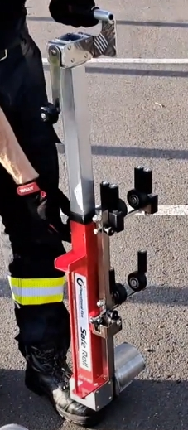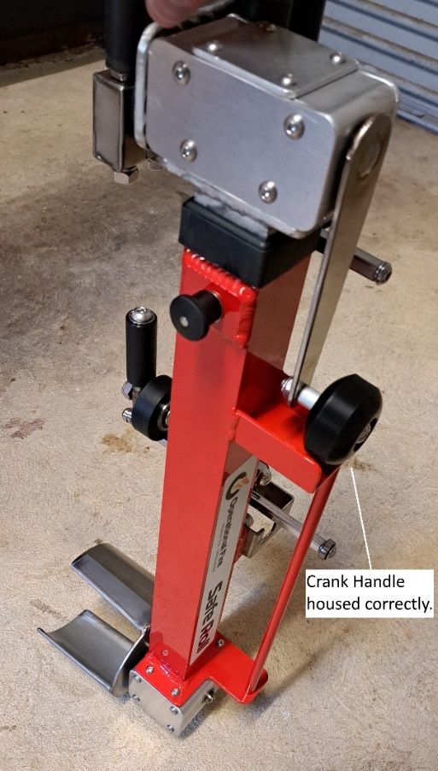
Figure 10: Collapse Safe Roll by pulling the pin. Ensure rubberised part of the grab handle is the only part to be used when collapsing Safe Roll.

CLEANING

Do not use abrasive cleaners of any kind.

Use a damp rag to wipe the Safe Roll clean. If heavily soiled, squirt clean with a hose.

MAINTENANCE

Visually inspect all parts of the Safe Roll on a weekly basis or immediately after use.

If any damage is detected (i.e. cracks, bends, loose parts, missing/illegible stickers) tag and return the item for repair or replacement.
It is important for hose life to ensure that any potential burrs on any of Safe Roll’s non-rotating parts are removed / rectified prior to use.

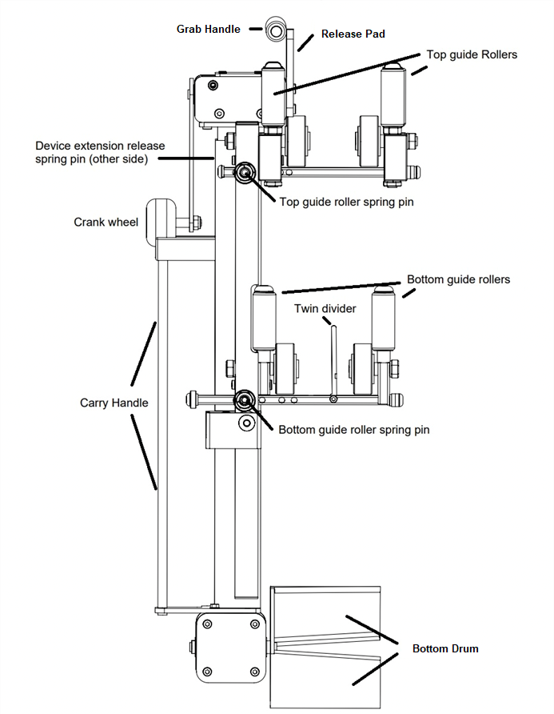
Figure 11: Safe Roll parts name / location diagram

